**SSN College of Engineering**

**Department of Computer Science and Engineering**

**CSI Student Chapter**

**Third CSI Project Colloquium 2019**

SSN-CSI student chapter organized a third CSI project colloquium event on 7th March 2019 for various Engineering students in the 17 domain areas. Enormous response was received from student community. 22 projects were selected to present their poster presentation.

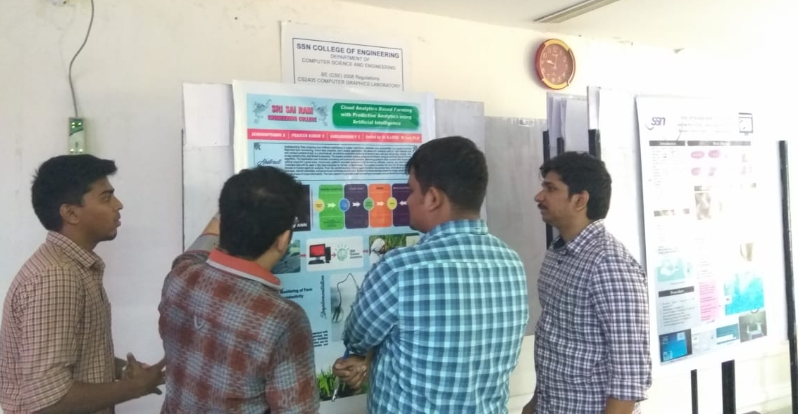

Following the talk, student poster presentation was judged by 6 judges.

1. Dr.C. Aravindan, Professor, Dept. of CSE, SSNCE
2. Mr.Sadhanandhan Balakrishnan, Program manager, Indium Software(India) ltd, Chennai
3. Mr.Balaji, Software Engineer, Chennai
4. Mr.Saravanan, CEO, Agmatic solutions, Chennai
5. Mr.Sriraghav, Software Engineer, Dell, Chennai
6. Mr.Roopeshwar D, Software engineer, Motorq, Chennai.

Students from various Engineering colleges presented their poster on the following topics.

|  |
| --- |
| K Reshma,D Priyanga,D Praisy grace jemema, *Multi-dimensional trust evaluation model*  Government College of Technology, Coimbatore. |
| Kathala Krishna Chaitanya Rao, Thogaru Sathvik, Komal Vyas, Thanuku Aishwarya., *A hybrid technique using principal component analysis and neural Networks for predicting breast cancer,* Jyothishmathi Institute of Technology &Sciences - JNTU-H, Telangana |
| ShriHarina J, Divyasshree, *MusIcon: Application for an Affective Experience,* Sastra Deemed University |
| K.Bhuvaneshwari, T.Keerthika Dharani, M.Gayathri, Mrs.N.Raji, *Detection of Soil Nutrient and Crop Prediction using ML.,* Jerusalem College of Engineering, Chennai |
| Nivedaa A, Sindu R, Mahalakshmi R, *Data Analytics method for Reporting Disease Outbreak in a region,* Sri Sairam Engineering College, Chennai. |
| S.Aarthi , S.Deepika, A.Jeyanth, R.Prabavathi., *Food Nutrition Analyzer For Fatal Disease Using Machine Learning With Arduino,* Jerusalem College of Engineering, Chennai. |
| Kovarthanan M, *Drones and IOT devices for water bodies monitoring and*  *help to eradicate water borne disease,* Prathyusha Engineering College, Chennai. |
| Badri Narayanan K V, Balaji R, *Water consumption analysis and flow based motor control using IOT,* Jerusalem College of Engineering, Chennai. |
| Dharani S, Harshini S, Kalaivani Kumaran, Logesh B, *Home Automation using Iot with speech recognition,* SSN College of Engineering,Chennai. |
| R.Srivatsan , Suriya .K, *Rocket India or Borewell India,* Easwari Engineering College |
| Ajay Nair, Harish Kumar .K, Hemanth .G, V.M. Kumar, *Web app based display system,* SSN College of Engineering. |
| Julie J, Sreeram G, Eniyan S, Srinivasan Raghavan M, *Live face: recollection system in live stream,* Sri Sairam Engineering College, Chennai. |
| R.Vigneshwaran, S Janarthanan, *Security and Surveillance using RF signals,*  A.V.C College Of Engineering. |
| Jaimahaprabhu A, Praveen kumar V, Gangadharan P S, *Cloud Analytics based Farming with Predictive analytics using Artificial Intelligence,* Sri Sairam Engineering College, Chennai. |
| RochanaaShri.M, Nithuna R L, V N Supriya, Sruthi V, *A Robotic System for Crime,* *A Robotic System for Crime Detection using Gait Analysis,* School of Engineering, Avinashilingam University, Coimbatore. |
| Pavithra S, Ramya S, *Maintaining integrity and multiowner data sharing using blockchain in cloud storage,* Sri Sairam Engineering College, Chennai. |
| Aashish A, Arunima S, *Integrated Home Security system,* SSN College of Engineering. |
| Vijayalakshmi.P, Vaishnavi.V, Sameena Fathima.M, Priyanka.K, *Private car pooling in mobile application,* St.Joseph's College of Engineering, Chennai |
| Abirami S, Aparajith Srinivasan, Divya N, *Multilevel Safety System for Children*, SSN College of Engineering |
| Boaz Prem Raj . S, Deepak Kumar . D, Karthick . P, Mukesh . V, *Smart Wheelchair with Healthcare*,  Jerusalem College of Engineering |
| Ajitha Joan.A, Abishake.R, Indu. G, Mervin.H, *Brain tumor detection and segmentation using convolution neural network in MRI images*, Jerusalem College of Engineering. |

Best three posters were selected and gift voucher was presented. Thanks for the volunteers and participates to end the program successfully.

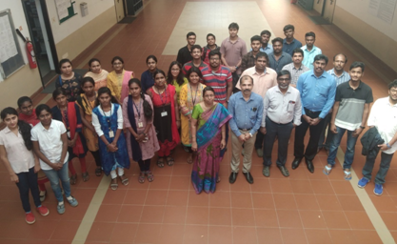

Vishal Raj N N

Rohit K R

Mohanram P B

Karthick Viswanath S